ESS Round 9

Summary reporting indicators in FMS SURVEY CTRL

By default, figures reported in the FMS are based on the information provided in the latest weekly file uploaded to the portal or the latest information synced from Case CTRL (if using FMS app).
It is also possible to select reports of the situation in a previous fieldwork week.
The current status of the case is defined by the outcome of the last contact attempt recorded by the interviewer. There is no prioritisation of outcome codes allowed.
Summary indicators
Indicator | Definition
Gross sample | N= Number of cases in gross sample  As agreed with sampling expert and signed off in Sample design summary and Fieldwork Questionnaire (FWQ)
Cases uploaded to Sample CTRL | N= Number of unique sample records currently uploaded to FMS upload portal  % = (Cases uploaded/gross sample)*100
Contact attempted | N= Number of cases with at least 1 contact attempt (in any mode) since the start of fieldwork  % = (N cases with at least 1 contact attempt/ Gross sample) * 100
Ineligible | N = Number of cases coded as ineligible at last contact attempt  i.e. case coded as:  7 = Invalid at Q5 on ESS Contact Form OR  8, 9, 10 at Q6 on ESS Contact Form  % = (N ineligible cases/gross sample) * 100
Response rate | N = Number of completed interviews achieved  i.e. case coded as:  1 = complete interview at Q5 on ESS Contact Form  %= (N interviews achieved/(gross sample-ineligible)) * 100
Non-contact rate | N= Number of cases where no contact achieved  i.e. case coded as:  6 = No contact at all at Q5 on ESS Contact Form  % = (N of cases with no contact/(Gross sample-ineligible))*100
Cooperation rate | N = Number of interviews achieved  i.e. case coded as:  1, 2 = complete or partial interview at Q5 on ESS Contact Form  % = (N of interviews achieved/(N interviews achieved + refusals))*100
N of interviewers active in selected week | N= Number of different interviewers making at least one contact attempt in seven day period  % = (N of active interviewers/All interviewers assigned to ESS Round 9)*100
N of interviewers achieving an interview in selected week | N = Number of different interviewers achieving a complete or partial interview in seven day period  % = (N of interviewers achieving an interview/All interviewers assigned to ESS Round 9)*100

Detailed outcome codes
This table gives the current status of the case as defined by the outcome of the last contact attempt recorded by the interviewer. Outcome codes are the same as those given in the ESS Round 9 Contact Form at Q6.
Percentages are calculated as a proportion of the gross sample.
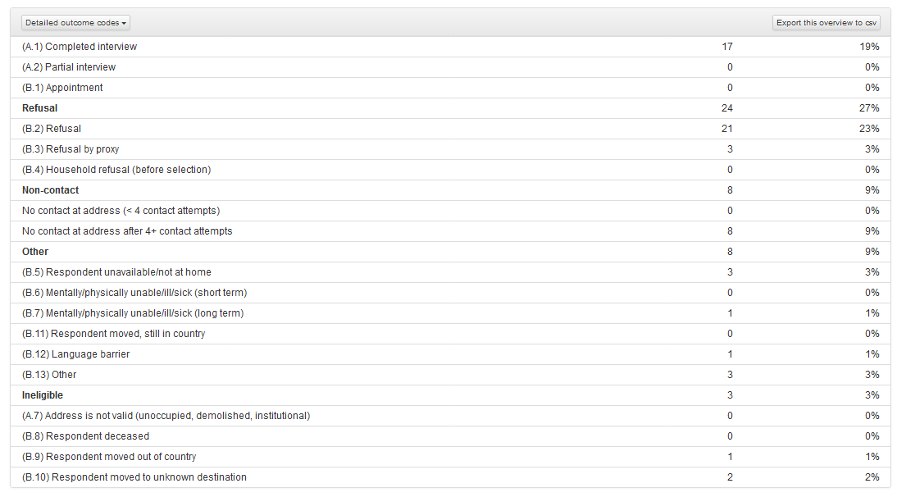

Breakdown
It is possible to see the status of cases broken down by the following sub-groups:
  - Batch
  - Region
  - Age group (if relevant)
  - Gender (if relevant)
  - Case status
  - Interviewer

The following figures are provided for each sub-group:

Column | Definition
Cases uploaded to Sample CTRL/FMS upload portal | Number of unique sample records currently uploaded to Sample CTRL
Contact attempted | Number of cases with at least 1 contact attempt (in any mode) since the start of fieldwork
Interview | Number of interviews achieved  i.e. case coded as:  1, 2 = complete or partial interview at Q5 on ESS Contact Form
Appointment | Number of cases coded as  1 = Appointment at Q6 on ESS Contact Form
Non-Contact | Number of cases where no contact achieved  i.e. case coded as:  6 = No contact at all at Q5 on ESS Contact Form
Refusal | Number of cases coded as  2, 3, 4 at Q6 on ESS Contact Form
Ineligible | Number of cases coded as ineligible at last contact attempt  i.e. case coded as:  7 = Invalid at Q5 on ESS Contact Form OR  8, 9, 10 at Q6 on ESS Contact Form
Other | Number of cases coded as:  5, 6, 7, 11, 12, 13 at Q6 on ESS Contact Form

Charts

The figures shown in the charts are derived as follows and show the cumulative result for each week in the field.

Chart | Definition
(Cumulative) number of interviews | N = Number of interviews achieved  i.e. case coded as:  1, 2 = complete or partial interview at Q5 on ESS Contact Form  Figures are given for:  - Achieved in current round  - Projection for current round  - Achieved in previous round (if available)
Response rate | (Number of completed interviews achieved/(gross sample-ineligible cases)) * 100
Cooperation rate | (Number of complete + partial interviews achieved/(N interviews achieved + refusals))*100
Percentage of cases receiving at least 1 contact attempt since the start of fieldwork | (Number of cases receiving at least 1 contact attempt/gross sample)*100

