Supplementary Online Materials (SOM)

Ten Hypotheses Generated for Increasing Survey Response Propensity Among Immigrants and Inhabitants of Socially Disadvantaged Areas

Index
Page 2. Table S1.
Page 3. S1. Description of Thematic Analysis
Page 4. S2. Results and Quotes supporting the results of the Focus Group Interviews
Page 17. S3. Confirmation Phase. Invitation Letters
Page 20. S4. Confirmation Phase: Survey Experiment
Page 22. S5. Confirmation Phase: Tables.

Table S1.
Demographics of the focus groups.
Age  16–21 years  22–27 years  28–33 years  34–39 years  40–60 years  60–70 years  No answer | 17 (52%)  4 (12%)  6 (18%)  2 (6%)  1 (3%)  2 (6%)  1 (3%) | Residential area  Askim  Biskopsgården  Kortedala  Central Gothenburg  No answer | 1 (3%)  21 (64%)  2 (6%)  2 (6%)  7 (21%)
Gender  Male  Female | 18 (55%)  15 (45%) | Swedish citizenship  Yes  No  No answer | 22 (67%)  9 (27%)  2 (6%)
Education  Primary, <9 years  Primary, 9–10 years  Secondary, ≤2 years  Secondary, 3 years  Post-secondary, <3 years  Post-secondary, ≥3 years  No answer | 8 (24%)  6 (18%)  2 (6%)  8 (24%)  2 (6%)  6 (18%)  1 (3%) | Born in …  Sweden, & both parents born in Sweden  Sweden, & both parents born in another European country  Sweden, & mother born in Sweden & father in another European country  Sweden, & mother not born in Europe & father born in another European country  Another European country, & both parents born in another European country  Country outside of Europe, & both parents not born in Europe  No answer | 7 (21%)  3 (9%)  1 (3%)  1 (3%)  5 (15%)  12 (36%)  4 (12%)
Occupation  Full-time employment  Part-time employment  Own business  Unemployed  Retired  Student  Other  No answer | 2 (6%)  4 (12%)  6 (18%)  1 (3%)  1 (3%)  14 (42%)  4 (12%)  1 (3%) | Marital status  Single and never been married  In a relationship and never been married  Married  Divorced and single  Widow/ widower and not in a new relationship  No answer | 10 (30%)  4 (12%)  10 (30%)  4 (12%)  2 (6%)  3 (9%)
Note: Percentages are rounded to whole numbers.

S1. Description of Thematic Analysis
In the first step of Braun and Clarke’s (2006) step-by-step guide to thematic analysis, the moderator and the project leader read the transcripts several times and shared reflections and initial ideas on the interviews. In the second step, keywords and sentences describing the essence of the data were coded by the moderator. Importantly, in the present analysis, the entire dataset was coded to avoid the risk of missing out on aspects that might be relevant. In the third step, themes were identified by analyzing the codes and checking whether codes belonged to overarching themes. This step resulted in a list of several candidate themes. In the fourth step, the candidate themes were reviewed. A few themes were identified as too broad or too complex and had to be separated into more distinct themes, whereas a few other themes were merged as they were not mutually exclusive. In the fifth step, definitions for each theme were generated by reading and rereading all the data belonging to each theme. Thereafter, an intercoder reliability test was conducted by an external coder with experience in conducting focus groups but without experience in survey methodology (see, e.g., Wibeck, 2010). Ten percent of the material was randomly selected and then categorized under the themes based on the definitions of each theme. The test had an agreement rate of 72.7%. The majority of the errors were related to subthemes 2.3. and 2.4. The description of these subthemes was clarified to resolve the discrepancies between the two coders. At the final step of the thematic analysis, vivid quotes/dialogues were selected to represent each theme and presented in the results section of the hypothesis generation phase in the main text.

S2. Results and Quotes supporting the results of the Focus Group Interviews

Main Theme 1: Perceptions of Societal Factors
One of the main themes that participants elaborated on centered on societal factors explaining why people choose not to participate in surveys. Within this theme, two subthemes were identified: (1) Opportunity to exert an influence – responsiveness by society; and (2) Trust and attitude toward the sender.
Subtheme 1.1. Opportunity to Exert an Influence – Responsiveness by Society. The most prominent subtheme, central to the majority of the focus groups, was the need for an opportunity to exert influence and responsiveness by society. Arguments within this theme were often long and developed, and participants frequently returned to this subtheme during the interview. In particular, the focus groups projected a strong willingness to influence issues in their own residential area:

Focus group 1.
- So if we sit down and talk about a youth club … maybe we’re participating in an interview to express that we want a youth club; then we’ll get something out of participating if it’s realized. And it’s like that, you want to fight for something …
– Yeah.
- You want something in the end. Something to work for, and that we get something out of in the end.
Yet many participants expressed that they thought their possibilities to influence things were usually limited and that there was a lack of responsiveness from the decision-makers. Participants described this lack of responsiveness and the limited opportunities to influence as a key reason for not participating in surveys:

Focus group 7.
- So, there is social exclusion, right? As I said, when people notice that nothing happens … do you understand? It’s completely pointless to answer a question if nothing happens about the issue. That’s the reason.
- Moderator: Okay, so you think that one of the reasons why people don’t answer is that they feel socially excluded?
- Yeah, nothing happens, you understand? It’s mostly in disadvantaged areas where people don’t answer, right?
- Moderator: Yes.
- Yes, that’s why … in disadvantaged areas, people want a change, maybe people don’t want it to be … – people want it to be better here, you know? So, if you don’t see a change where you live, then it’s completely pointless to answer questions.
- Yes, I agree completely.
- That’s right.
Subtheme 1.2. Trust and Attitudes toward the Sender. The groups also discussed whether it was possible to trust people and organizations and whether lack of trust was an obstacle to their participation in surveys. Participants who said they trusted people in general or that they trusted most authorities expressed that trust may be important for their willingness to participate in surveys as well as society in general:

Focus group 8.
- Older people are like children. Someone will call them and say, “We’re calling from the bank. Can you give me your account details? There’s a problem we have to solve.” They’re like children: They answer. It’s easy to fool them. I think … people are scared maybe. People are scared. And society’s moral level has sunk. It’s not like before. I’ve been living in Sweden for almost 30 years. When I came here, it was much better. People trusted each other more and became friends more easily. Now it’s not the same.
Many participants said they would be more likely to respond if they perceived the sender’s organization to be credible and trustworthy:

Focus group 5.
- If the questionnaire is from the police, I don’t think anyone would like to participate.
- Moderator: No?
- No, and not if it is from the social administration. But like this, from the university … I don’t have any problems with that.
- It’s like, “Help me, help you.” You help us, and we help you with your study so … for example, your boss or your teacher or whoever it is … I mean it gets better for you and better for us.
- Moderator: But do you trust the police and the social administration less, or why …?
- Yeah, exactly. Or people have problems with them. People feel hatred. I mean real hatred toward the police. So, should they sit down and answer their questionnaires? It doesn’t work like that. It won’t work.
- The police usually push people down in these areas, you understand? Areas like this, not just this area, many areas. Maybe they see someone with a bag and they think “Drug dealer,” and they approach you and ask questions. It’s happened to me several times. From nowhere they appear and say, “Your eyes are red. It looks like you’re on drugs,” or something like that. Then they take a test and it’s negative. But still, they want a reason for …

Main Theme 2: Characteristics of the survey
In the second main theme, the characteristics of the survey were identified as influencing response propensity across four subthemes: (1) Financial incentives; (2) Method and recruitment strategy; (3) Design of the questionnaire; and (4) Framing and style of the questionnaire.
Subtheme 2.1. Financial Incentives. Participants discussed the importance of direct rewards–such as money or gift cards–for participating in surveys:

Focus group 8.
- … as I said, incentives. That you get some kind of reward. Because I mean, usually … if we’re talking about adolescents, there might be questions that they aren’t that interested or involved in: Compared to adults who work and have children and a car and …, you know? So then you might have to give them something small. A scratcher lottery ticket or whatever.
However, not all focus groups felt that incentives were a prerequisite for participation. For instance, one participant expressed that the opportunity to influence policy was a stronger mechanism for participation than financial incentives:

Focus group 5.
- It’s not only about that. If you answer and see a change, you will do it without getting any reward, do you understand? If you see that something is really going to happen.
Subtheme 2.2. Method and Recruitment Strategy. Moreover, participants tended to discuss the pros and cons of different ways of answering surveys. Whereas some participants argued they would be more likely to participate if receiving a paper-and-pencil questionnaire, others said paper questionnaires were the least appealing for them and preferred online questionnaires. Some participants mentioned the positive aspects of face-to-face interviews, and hardly anyone had anything negative to say about such interviews. For brevity of presentation, the opinions of different survey modes are summarized in Table 3 (for detailed excerpts, see SOM, S2). Furthermore, participants elaborated on different innovative recruitment strategies that might increase the response propensity among immigrants as well as among young people:

Focus group 4.
- Moderator: Do you think something can be done to get more people to answer?
- Yes, maybe you can go to the Swedish Migration Agency. In the queue. They can answer the questions.
– Or go to SFI schools.

Focus group 5.
Starting with mail questionnaires, some perceived these to be an inefficient way of recruiting participants and felt that they were too demanding:
- Do you mean that you send these out by mail?
- Moderator: Yes.
- Who would … I mean … who would sit down voluntarily …
- But not only that … do you have to return it as well?
- Moderator: Yes.
- No, no, wait, wait, wait.
- Yes, it’s a lot of work.

Table S2.
Opinions about different data collection methods.
Method | Positive | Negative
Mail questionnaire | “Easy to get a picture of what the survey is about.”  “Elderly people are likely to prefer mail surveys over online surveys.” | “It’s a lot of work.”  “What 17/18-year-old is going to sit down and check the mail?”
Online questionnaire | “Young people are more likely to answer online surveys than mail surveys.” | “Not reliable: I don’t want them to see me online.”
Face-to-face interview | “You might feel more comfortable if you see the person.”  “Easy to ask follow-up questions and get help if you don’t understand.” | N/A
Phone interview | N/A | “You don’t see the person.”
Note: Quotes from the nine focus groups. N/A = not applicable.
Focus group 9.
On the other hand, some participants said that they preferred mail questionnaires over online questionnaires, as they thought that mail questionnaires were more secure and provided an easier overview of the questionnaire:
- Moderator: And here we have two letters that are sent out to get people to join online surveys.
- I’ve received this.
- Moderator: Have you been asked to join an online survey?
- Yes.
- Moderator: Did you join?
- No, I refused.
- Moderator: What made you decide not to join?
- I didn’t want them to see me online.
- Moderator: So, you thought that it wasn’t that safe because it was online?
- Exactly.
- Moderator: Would you, for example, trust a mail questionnaire more?
- Yes.
- Because in today’s society, you can do 1,000 different things online. That’s why it might not be reliable.

Focus group 6.
- Sending it by mail is good too. Because then you have an opportunity to look at it and see what it’s about.

Focus group 8.
Another central feature of this subtheme was that most participants appeared to prefer face-to-face interviews over other modes. The personal contact with the interviewer in face-to-face interviews seemed to be key:
- I also think it’s about what attitude you have as an interviewer. How you approach people. It might be much more convenient when you introduce yourself and tell where you come from. Who you are and what kind of questionnaire it is. Compared to answering a phone call. Then you don’t see the person. You might be more comfortable if you see the person.

Focus group 2.
Another benefit of personal interviews that was raised during the interviews was that it was easier to ask follow-up questions if you did not understand the question:
- I don’t remember which company it was, or what it was about. But anyway, I looked through it. I didn’t understand that much, but I tried a bit. But then I finally got tired so I threw it out.
- Moderator: Okay, did you get tired because it was too long, or because the questions were …
- I didn’t really get the questions so …
- Moderator: Okay, so the questions weren’t clear …
- Yes, but when I’m at the center, I can answer this kind of question.
- Okay, so it’s more difficult if it’s sent home?
- Yes, it gets … I don’t understand … Imagine you don’t understand the question. It takes a long time to look it up. So, if you’re at the center and they ask the same questions, then you can at least get help.
Subtheme 2.3. Design of the Questionnaire. The participants discussed technical aspects of the survey that they said influenced their likelihood of responding. These included the amount of information in the questionnaire, the length of the survey, and the design of the survey questions (e.g., open-ended questions vs. fixed response options). One prominent view was that a lengthy survey would negatively affect willingness to participate.

Focus group 2.
- Look at how many pages this is [referring to a questionnaire from the SOM Institute].
- It’s like a national university aptitude test.
- Look at this! I can be honest: You would look at this. You’d open it. Then you’d see all this, and you’d just throw it out.
– Moderator: You don’t think that people would even look at the questions?
- Well, you read the first sentence and then: “Okay, there are just questions like that.”
- Ten percent of people may read the whole thing.
– If they are retired.
- Yeah, exactly.
Another aspect of this theme was the design of the questions. Some participants said they preferred being offered response options over being asked open-ended questions:

Focus group 1.
- I like this! It’s checking-off-questions.
- Yes!
- It’s really nice because it’s fun to make a check, haha! Because if I see a lot of text I think: “I don’t have the energy for this.”
- Or, like: “What does this mean?” And then you’re supposed to write this much [participant demonstrates how much with her hands]. If I have to sit down and write, you probably won’t get detailed answers. I would probably just write two words and then just: “Never mind, I can’t cope.” But to answer this, you have to read and think a little.
Subtheme 2.4. Framing and Style of the Survey. The participants discussed how the style of the text in a survey and the visual aspects affected their first impression of the survey: For instance, it could make the survey look important, serious, boring, difficult, or interesting. Under this subtheme, many participants mentioned that it could be off-putting if the survey looked formal and that simple language would be beneficial, especially for immigrants:

Focus group 1.
- This has got very formal language [participant is referring to the SOM questionnaire]. Those who move to Sweden … I mean, I have friends from other countries. They have good Swedish skills. But they know a more everyday language, and then it might feel uncomfortable: To participate in an interview where they know that there will be a lot of formal and complicated words. Words that they might not understand. It will also make them feel stupid.
- There are often difficult words in questionnaires. So, you may not understand all the words.
Whereas many participants agreed that less formal language would encourage participation, different views were expressed regarding the visual aspects and the degree of formality in the survey. Some participants wanted more color, figures, slogans, and pictures, whereas others thought the invitation and survey should look formal to make a serious impression:

Focus group 1.
- Well, I think this one looks scary [participant is referring to an envelope]. It feels like: “I’ve received a letter from school and now my parents will be super upset.”
- Hahaha!
- And this one feels more like: “Oh, how fun! What is this?” [participant is referring to an invitation that looks rather like a postcard]
- Yes exactly, it looks super personal.
- And that’s what adolescents like. We get hooked on the sentence: “What do you think?” [participant is referring to the headline of the invitation]
- We like ourselves. Haha! We’re selfish!
- Hahaha!

Focus group 8.
- Maybe it’s more paper [participant is talking about the letter and envelope, compared to the postcard]. So, it’s not good for the environment. But the envelope is more secure.
- I agree. The envelope looks better. It looks more serious.
- It’s credible. The envelope is the most secure.
- I agree that it is more credible, but I think that one [the postcard] looks nicer. I mean, compared to a boring envelope. It’s a little more color and a little … that can be a factor as well. But this looks for sure more … safe.
Moreover, participants discussed different ways to frame or “sell” the survey. For example, emphasizing that the participant was important and valuable and that their opinions would affect the outcome of the study would increase survey participation:

Focus group 7.
- And, like I said, I think it should be clearly described how this will affect me. If I answer, like, if I give you my time … because often you don’t get a reward. You said we’ll get a gift card, but normally you get nothing for participating. So, you must give me a good reason for spending my time on this. For free. I really have to know how this will affect me or society or the world. How will my voice, my opinion, and my habits – that you want to know about. How will they help to answer questions about this? You know what I mean? This must be stated clearly but briefly.

Main theme 3: Individual-Level Factors
Finally, participants elaborated on individual-level factors they thought might influence the likelihood of participating in surveys across three subthemes: (1) Interest, engagement, and perceived self-efficacy; (2) Language skills and understanding of questionnaires; and (3) Attitudes toward the sender.
3.1. Interest, Engagement, and Perceived Self-Efficacy. Several participants believed that interest and engagement were key factors for participation. Interest and engagement often depended on whether the issue was perceived as important:

Focus group 2.
- If it’s about yourself, then, of course, you’re willing to join, you know what I mean?
- Mm.
- Then it’s more interesting to answer.
- Moderator: If it’s about yourself?
- It doesn’t have to be personal but about things around me. Things that happen, things I see, things I know, things I can relate to.
Perceived self-efficacy/competence in answering the questionnaire was also discussed.

Focus group 1.
- It’s more fun to talk about your own life because you have knowledge about that. You know what you’re doing, and things like that … If someone would ask, “What do you and your friends usually do?,” I would answer. It’s a bit more fun to talk about because I have knowledge about that. And when you talk about politics, you might not be that good at it.
- And then you’ll probably feel a little stupid. You might get embarrassed because you feel like “Oh, I don’t know anything. Now I look stupid.”
- “And now I’m trying because I want to.” But it doesn’t work … I mean, I can’t.
Subtheme 3.2. Language Skills and Understanding of Questionnaires. Furthermore, the focus groups expressed that Swedish language skills and understanding the survey were important to get them to participate in surveys:

Focus group 6.
- I received questionnaires from the housing company. Sometimes, at the end of the year, they ask questions like “Is everything alright?” But I don’t answer.
- Moderator: You don’t answer?
- Sometimes they send questionnaires, for instance, the doctor. They ask if I’m sick or if there are any other problems. But it’s in difficult Swedish. I don’t understand much.
- Difficult words.
- There might be three pages. We aren’t able to understand three pages. It takes a long time to translate.
Many participants thought that translating questionnaires might increase survey participation:

Focus group 1.
- Yes, but do the questionnaire in several languages, and stuff. As we said before. It helps a lot, I think.
- And then you would involve different ethnicities in the questionnaires. Because Sweden consists of lots of different ethnicities, and stuff, and it would be good to get everyone’s view. People come from different places, so they also have experiences about things like, different politics. And they can also compare, so they will give you even more opinions. Or make you get more out of it.

S3. Confirmation Phase. Invitation Letters
S3.1. Translation of the Treatment Vignette Appearing within the Light-Blue Box of the invitation Letter.
In the preparation of previous citizen promises, the people of Trollhättan have been able to share their opinions by completing an interview on the municipality’s or the Police’s websites. However, it appears that only certain individuals from a few specific areas of Trollhättan found that questionnaire. This year, we want to increase the likelihood that you and others living in your area influence what the next year’s citizen promise will be about. By answering the questions of this questionnaire, you can make a difference and improve the area where you live.

Figure S1. Letter without the information that tells participants that answering the questionnaire may increase their chance to influence a policy.
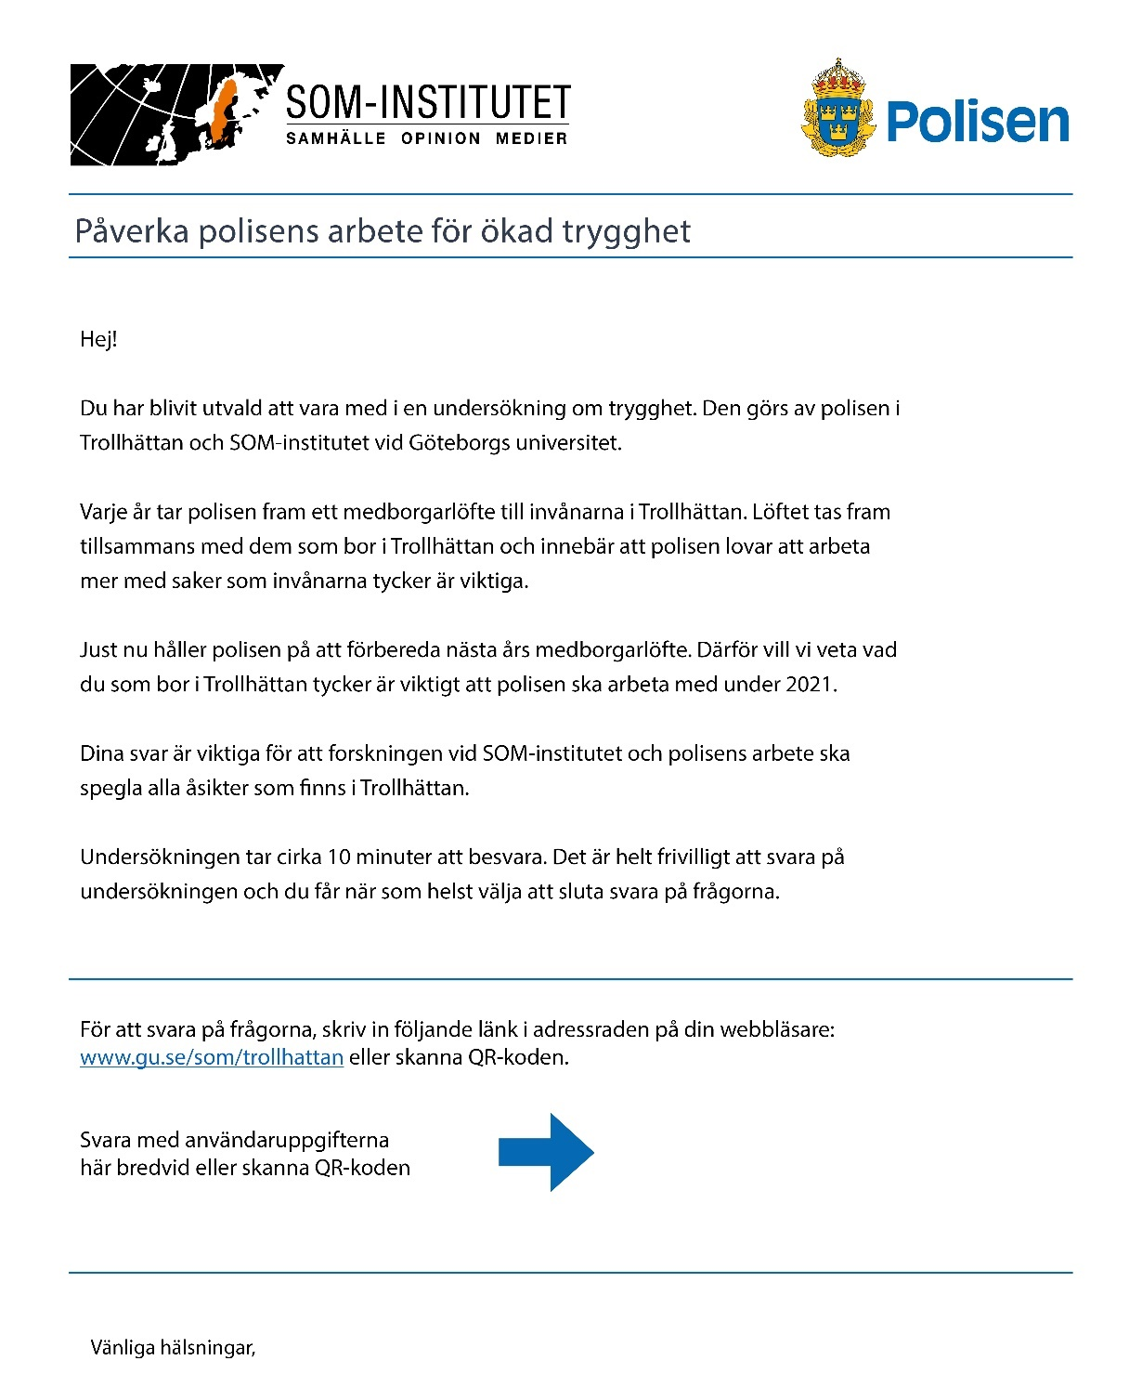

Figure S2. Letter with the information that tells the participants that answering the questionnaire may increase their chance to influence a policy.
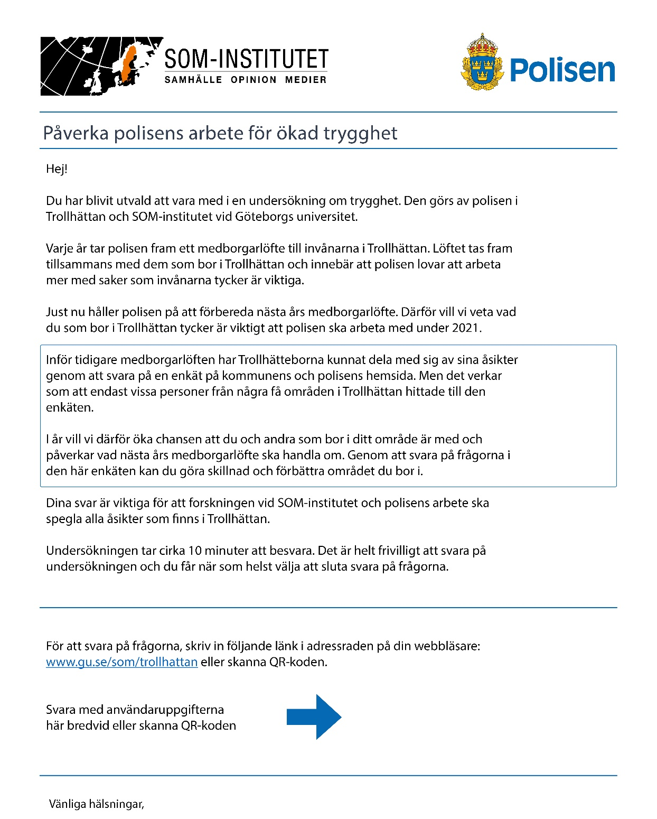

S4. Confirmation Phase: Survey Experiment

Measures
Response. Participants who completed 80% or more of the applicable questions were coded as 1 (response) and 0 (nonresponse) otherwise. Response propensity was calculated using response rate 1 (RR1) according to the American Association for Public Opinion Research (AAPOR)’s definition (AAPOR, 2016).
Nonresponse Bias. Nonresponse bias was assessed by estimating so-called “representativity indicators (R indicators)” (Schouten et al., 2009). The R indicators are an expression of the standard deviation (SD) of probabilities of responses of units in the population. The R indicators were estimated by fitting a logit regression predicting response with registry data on the participants’ age group (16–24, 25–29, 30–39, 40–49, 50–59, 60–75, and 76 years or older), sex, and birth country (born in Sweden/not born in Sweden), and estimating Eq. 1 (Eq. 5 in Schouten et al., 2009, and unadjusted R indicators in the R script created by de Heij, Schouten, & Shlomo, 2015).
$$1-2 \sqrt{\frac{1}{N-1}\sum_{i=1}^{N}{{\left(ρ_{i}- \overline{ρ}\right)}^{2}}}$$

Eq. 1.

Data Quality. In similarity to other studies on response propensity interventions (e.g., Oscarsson & Arkhede, 2019), the impact of the manipulation on measurement error was assessed by estimating item nonresponse, length of responses to open-ended questions, and non-differentiation (straight-lining).
Percentage of Questions Answered. The percentage of questions answered was estimated by calculating the proportion of questions a participant did not answer out of the total number of questions in the questionnaire (the questionnaire included no filter questions or skip logic, so everyone was eligible to answer all questions). All participants who started the questionnaire and answered at least one question were included in the measure. Participants who did not answer a single question were coded as missing.
Characters Typed in Open-Ended Questions. The number of characters written in the open-ended questions was estimated for each participant as one of the data quality measurements. All participants who saw an open-ended question were included in the analyses; participants who saw an open-ended question but did not type any characters were coded as 0.
Non-differentiation (Straight-lining). Non-differentiation was estimated by identifying participants who gave the same response to all items in a grid-type question. A participant who gave the same response to all items was coded as 1; participants not giving the same response throughout were coded as 0. Participants who did not answer at least one of the items were coded as missing.
Covariates. Socially Disadvantaged Area. A variable called socially disadvantaged area was coded 1 for participants who were registered as living in zip codes 46160–46167, and 0 for participants who were registered as living in zip codes 46132, 46140–46144, and 46192.
Immigrant. A variable called immigrant was coded 1 for participants who were registered as not born in Sweden and 0 for participants who were registered as born in Sweden.

S5. Confirmation Phase: Tables.

Table S3. Ordinary least squares (OLS) regression results predicting response with treatment and covariates.
 | Completed the questionnaire
Predictors | Opportunity to exert an influence | Opportunity to exert an influence, and socially disadvantaged area | Opportunity to exert an influence, and immigrant status
Manipulation
Message about exerting influence | 0.03 (0.03) | 0.07 (0.05) | 0.04 (0.04)
Covariates
Socially disadvantaged area |  | -0.10* (0.05)
Not born in Sweden |  |  | -0.08⁺ (0.05)
Interaction
Message about exerting influence * Socially disadvantaged area |  | -0.09 (0.07)
Message about exerting influence * Not born in Sweden |  |  | -0.05 (0.07)
Constant | 0.31*** (0.02) | 0.36*** (0.03) | 0.34*** (0.03)
R² | 0.00 | 0.03 | 0.01
Note: N = 800. Entries are unstandardized regression coefficients. Standard errors in parentheses.
⁺p < .1; *p < .05; ***p < .001.

Table S3. Ordinary least squares (OLS) regression results predicting response with treatment and covariates.
 | Completed the questionnaire
Predictors | Opportunity to exert an influence | Opportunity to exert an influence, and socially disadvantaged area | Opportunity to exert an influence, and immigrant status
Manipulation
Message about exerting influence | 0.13 (0.15) | 0.27 (0.21) | 0.18 (0.19)
Covariates
Socially disadvantaged area |  | -0.49* (0.22)
Not born in Sweden |  |  | -0.39+ (0.23)
Interaction
Message about exerting influence * Socially disadvantaged area |  | -0.43 (0.31)
Message about exerting influence * Not born in Sweden |  |  | -0.23 (0.32)
Constant | -0.81*** (0.11) | -0.56*** (0.15) | -0.66*** (0.14)
Pseudo-R² | 0.00 | 0.02 | 0.01
Note: N = 800. Entries are unstandardized regression coefficients. Standard errors in parentheses.
⁺p < .1; *p < .05; ***p < .001.

Table S5. Logistic regression results for the R-indicator estimation.
 | Completed the questionnaire
 | No message about exerting influence | Message about exerting influence
Individual characteristics Immigrant
Not born in Sweden | -0.38 (0.23) | -0.81** (0.25)
Sex
Female | -0.18 (0.22) | -0.09 (0.22)
Age
25 to 29 | -0.23 (0.55) | 0.50 (0.48)
30 to 39 | 0.38 (0.41) | 0.26 (0.43)
40 to 49 | 0.62 (0.41) | 1.69*** (0.43)
50 to 59 | 0.56 (0.41) | 0.75+ (0.42)
60 to 75 | 0.77* (0.38) | 1.19** (0.39)
76 or older | 0.64 (0.46) | 0.00 (0.50)
Constant | -1.04** (0.32) | -1.08** (0.33)
Pseudo-R² | .02 | .07
Note. N = 800. Entries are logistic regression coefficients. Standard errors in parentheses.
⁺p < .1; *p < .05; **p < .01; ***p < .001.

Table S6. Ordinary least squares (OLS) regression results predicting the proportions of questions answered with treatment and covariates.
 | The proportion of questions answered
Predictors | Opportunity to exert an influence | Opportunity to exert an influence, and socially disadvantaged area | Opportunity to exert an influence, and immigrant status
Manipulation
Message about exerting influence | 0.00 (0.02) | -0.01 (0.02) | -0.02 (0.02)
Covariates
Socially disadvantaged area |  | -0.06* (0.03)
Not born in Sweden |  |  | -0.06* (0.03)
Interaction
Message about exerting influence * Socially disadvantaged area |  | 0.02 (0.04)
Message about exerting influence * Not born in Sweden |  |  | 0.06 (0.04)
Constant | 0.95*** (0.01) | 0.97*** (0.02) | 0.97*** (0.02)
R² | 0.00 | 0.02 | 0.02
Note. N = 800. Entries are unstandardized regression coefficients. Standard errors in parentheses.
*p < .05; ***p < .001.

Table S7. Ordinary least squares (OLS) regression results predicting the number of characters written with treatment and covariates.
 | The number of characters written
Predictors | Opportunity to exert an influence | Opportunity to exert an influence (excluding DV outlier) | Opportunity to exert an influence, and socially disadvantaged area (excluding DV outliers) | Opportunity to exert an influence, and immigrant status (excluding DV outliers)
Manipulation
Message about exerting influence | -88.65* (44.72) | -15.71 (20.12) | 3.95 (25.92) | -7.03 (24.15)
Covariates
Socially disadvantaged area |  |  | 11.52 (29.76)
Not born in Sweden |  |  |  | -29.69 (30.35)
Interaction
Message about exerting influence * Socially disadvantaged area |  |  | -54.85 (41.43)
Message about exerting influence * Not born in Sweden |  |  |  | -46.90 (43.30)
Constant | 370.33*** (32.52) | 229.23*** (14.80) | 224.12*** (19.82) | 240.15*** (18.41)
R² | 0.01 | 0.00 | 0.01 | 0.03
Note. N = 800. DV = dependent variable. Entries are unstandardized regression coefficients. Standard errors in parentheses.
*p < .05; ***p < .001.

